Mirror Trading International (Pty) Ltd – IN LIQUIDATION
- HOW TO LODGE A CLAIM

  - Claims can be lodged online at: https://mticlaims.co.za
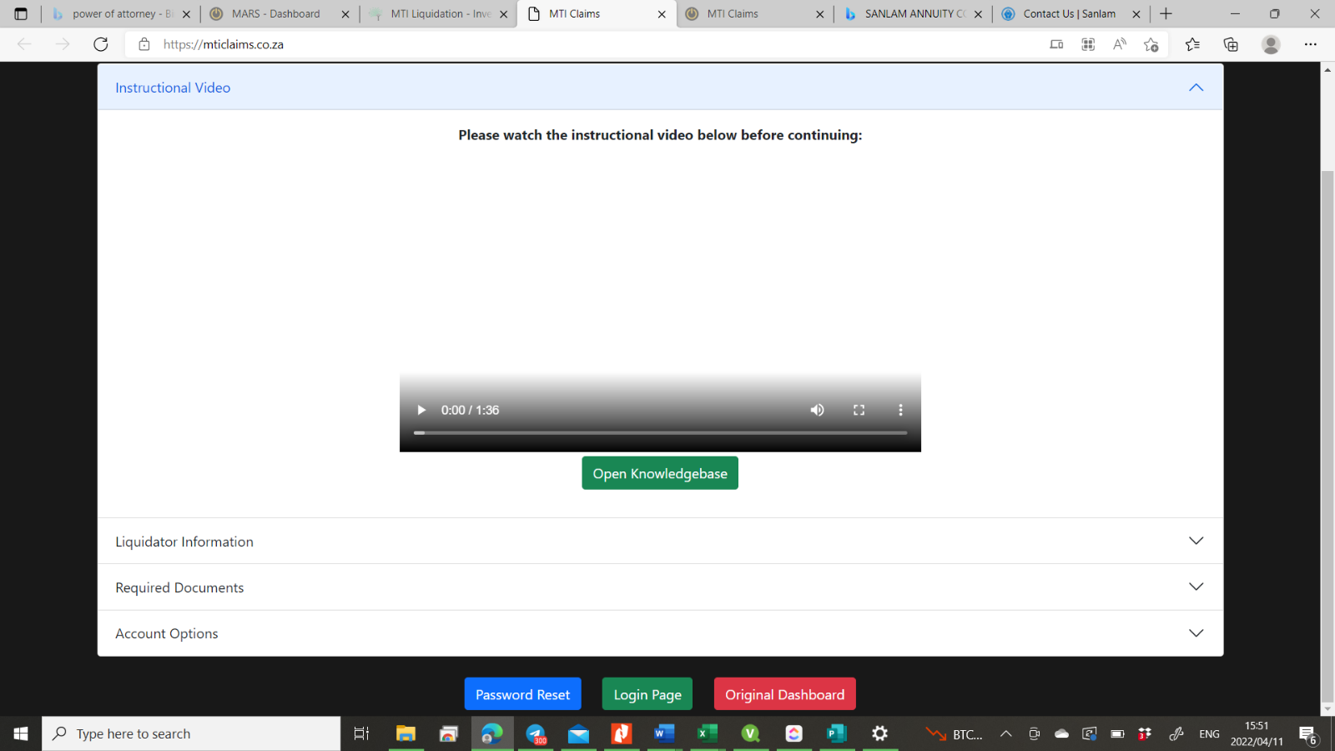
Step 1 – PLEASE WATCH THE INSTRUCTIONAL VIDEO

Step 2 – Click on the BLUE Password Reset Button to reset your password.
Step 3 – Enter your MTI UserID or MTI Username and the email address you used in MTI.
A Password reset link will be sent via email. Please check your Spam/Junk Folder as well.
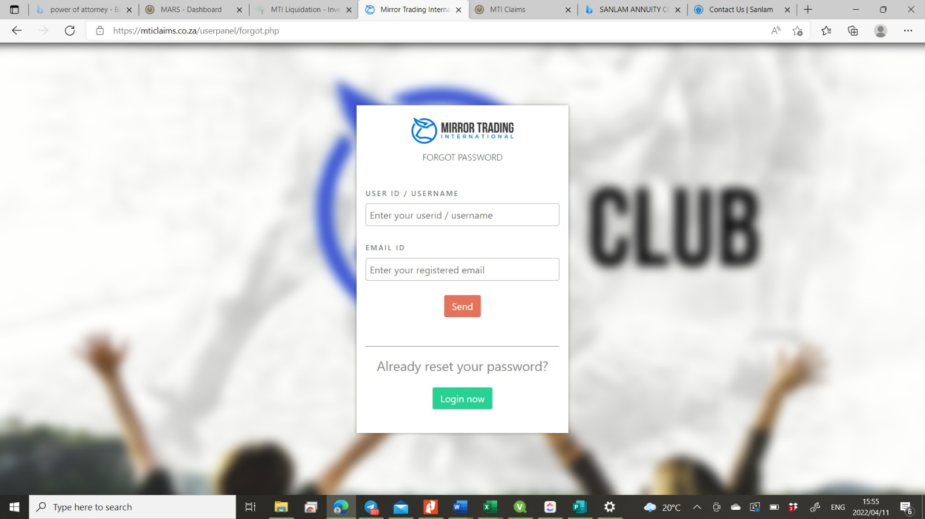

You will be required to upload the following Documents:
# | Title | Description
1 | Your Identification Document | Verification of your Identity in your respective country
2 | Your Bank Letter | A cover document of your bank account to prove the account is in your  name
3 | Your Claim Document | To be filled in completely and scanned together with all additional  documents

Step 4 – Complete the claim form.
Step 5 – Obtain the supporting documents to proof your claim.
Supporting documents: You need to give proof of the bitcoin you deposited to MTI – For example: Bank statement to proof the bitcoin bought – Statements or screenshots from the exchange where you transferred the bitcoin to MTI.
Add an additional note if you had multiple accounts in MTI. Make a list of all the other accounts and add it to your claim document.

Step 6 - Scan the documents in PDF Format.
Scan 1: Your Identification document

Scan 2: Bank Confirmation Letter (A letter from the bank confirming the bank account belongs to you)

Scan 3: Claim document
Supporting documents (Statements)

Step 7 – Upload your documents on https://mticlaims.co.za

Step 8 – Wait until you receive an email from claims@mticlaims.co.za to “accept” or “reject” your claim. Please note: This will not happen the same day. Your claim will be sent for verification and only after the claim is verified, you will receive an email. The claims will be done in batches as it will be impossible to process all the claims at once.

- HELP AND ASSISTANCE

Should you require any assistance in lodging your claim, please send an email to: MTIClaims@investrust.co.za or send a WhatsApp to +27846353871.

- FREQUENTLY ASKED QUESTIONS

  - Where can I lodge my claim?
https://mticlaims.co.za

  - Why do I need to upload my identification document?
A process called KYC needs to be done – we need to verify that you are the individual who are eligible to lodge the claim.

  - I need to lodge a claim on behalf of my minor child.
You will need to include the birth certificate of the minor child. Also make note in the claim than you are claiming on behalf of the minor child.
Example: Name of creditor in Full – John Doe (on behalf of Jane Doe minor)

  - My Back Office data is not available?
Please send an email to MTIclaims@investrust.co.za with your UserID.

  - My Back Office data does not correspond with the screenshots I took in December.
Please send an email to MTIclaims@investrust.co.za with your UserID.

  - How do I know if my claim is received?
If you lodge your claim online, you will receive an email to notify the claim was uploaded successfully.

  - How long will it take before my claim is paid?
At this stage the liquidators are awaiting the outcome of the Court case of 29 April 2022.
Unfortunately a date can’t be set at this stage.

  - Someone else transferred the Bitcoin on my behalf into MTI, I don’t have proof of the transfers. How can I proof my claim?
You need to obtain proof from the person who made the transfers.

  - What is the deadline to submit claims?
There is no deadline yet. As soon as a deadline date is set, all MTI members will be notified via email. It is advised that you lodge your claim as soon as possible.

  - Where can I get updates on the claim process?
https://www.investrust.co.za/mti-liquidation.html
https://www.tygerbergtrustees.co.za/mirror-trading-international-pty-ltd.html

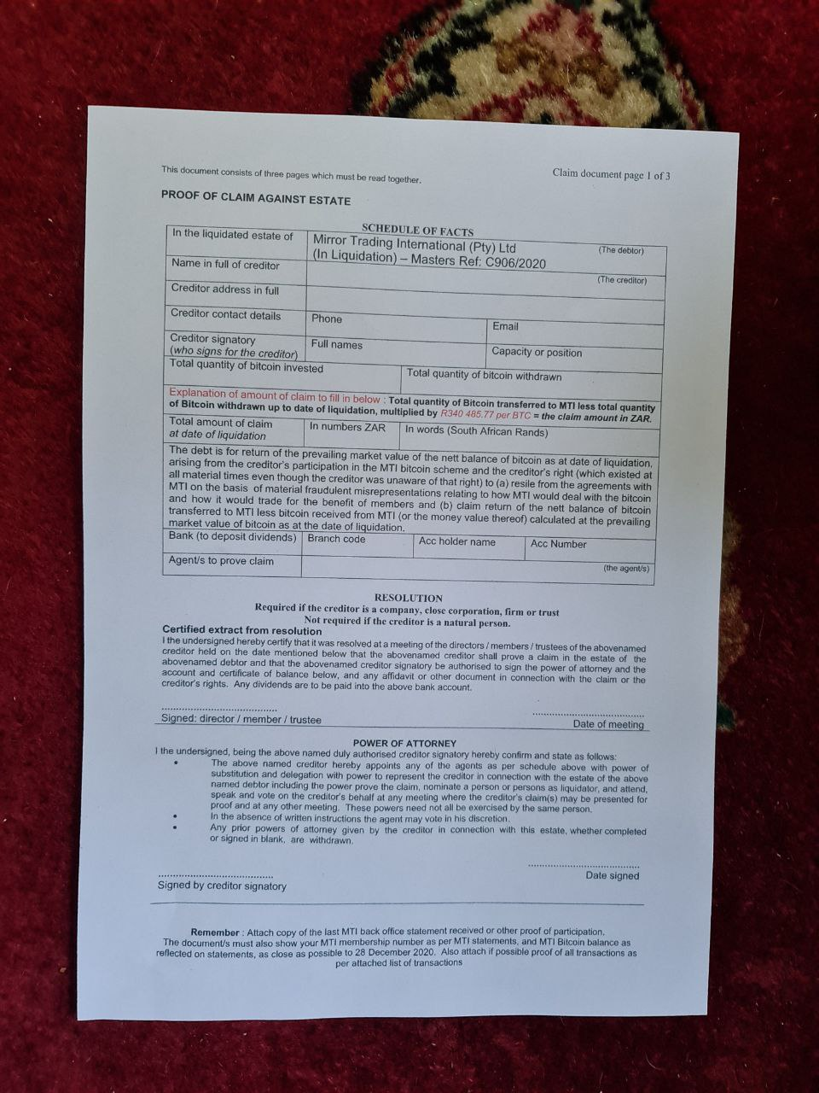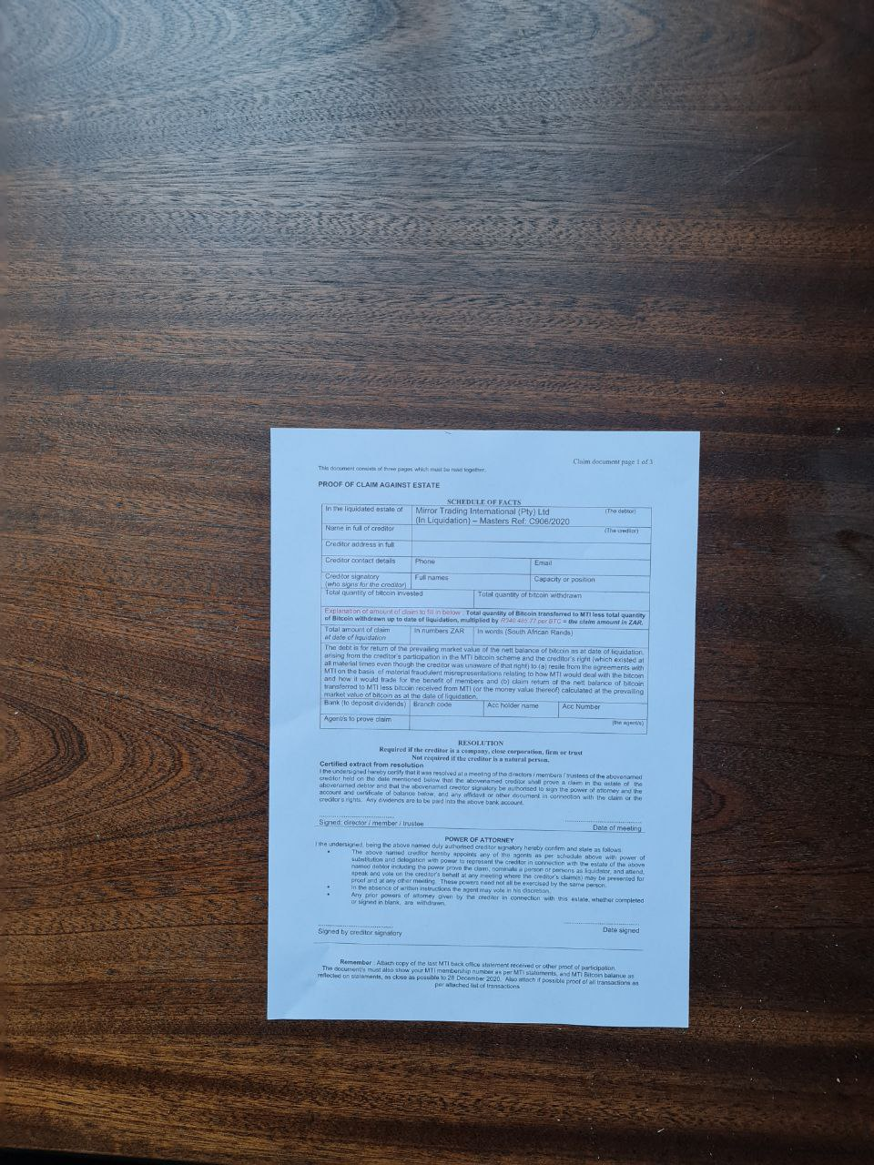
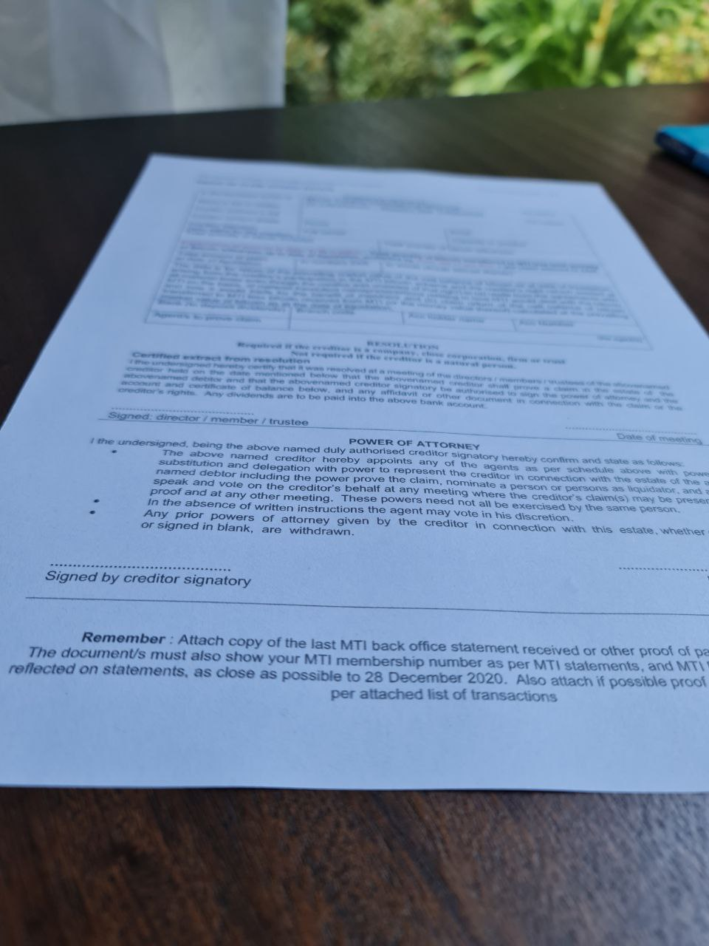
Please send scanned copies of your documents.
You will only be able to upload PDF documents on the mticlaims.co.za website.
https://www.pdf2go.com can be used to edit pdf documents

